**Name: Session:**

**Programming II**

**Lab Exercise 4/2/2021**

**Functions**

1. The Acme Wire Corporation sells spools of copper wire for $100 each. The normal delivery charge is $10 per spool. Rush delivery costs $15 per spool. Create an application that displays the status of an order. The status should include the following:

* The number of spools ready to ship
* The number of spools on backorder
* The shipping and handling charges
* The total amount due

The user should enter the number of spools ordered into a text box, and check a Rush Delivery checkbox if rush delivery is desired. When a Calculate Total button is clicked, an input box will open and ask the user to enter the number of spools currently in stock. If the number of spools ordered is more than the number of spools in stock, a portion of the order is back-ordered.

The application needs to have the following functions:

* getInStock – displays an input box asking the user the number of spools in stock. The function should return the value entered by the user.
* readyToShip – accepts the following arguments: the number of spools in stock and the number of spools ordered. The function returns the number of spools ready to ship
* backordered – Accepts the following arguments: the number of spools in stock and the number of spools ordered. The function returns the number of spools on backorder. If no spools are on backorder, it returns 0.
* shippingCharges – Accepts the following arguments: the number of spools ready to ship and the per spool shipping charge. The function returns the total shipping and handling charge

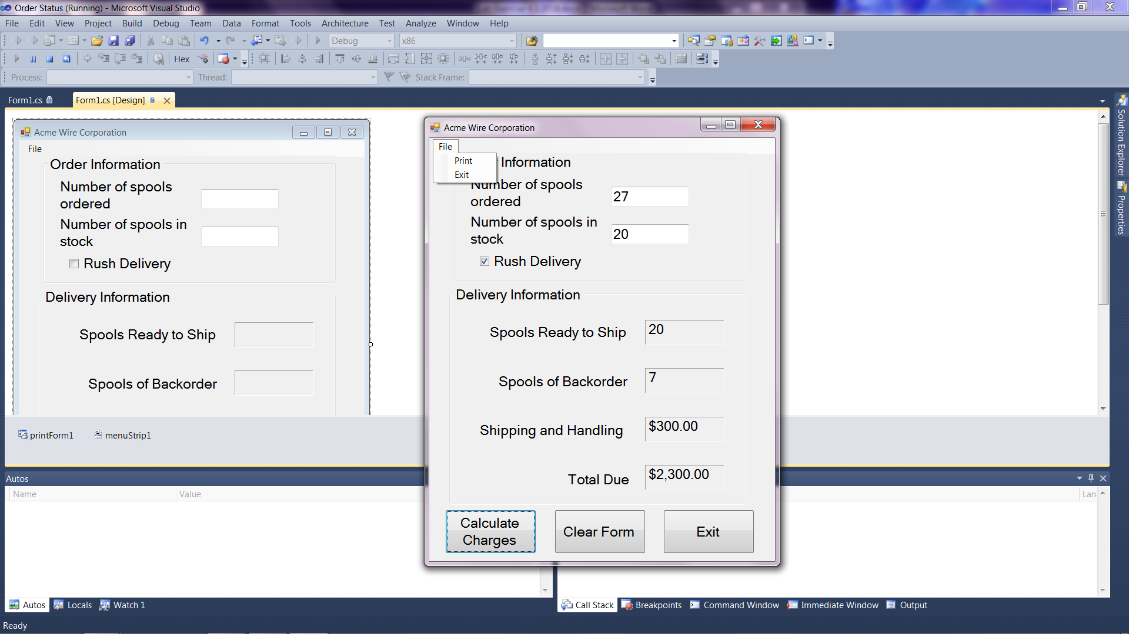

**When you complete your application, submit your source code and a screenshot of your running program.**